- Zk version 5.0.10, Java(TM) SE Runtime Environment (build 1.6.0_26-b03)
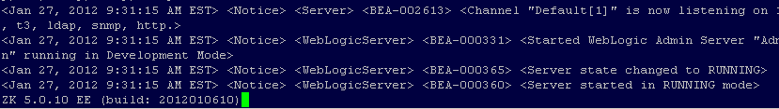
- When clicked on one row
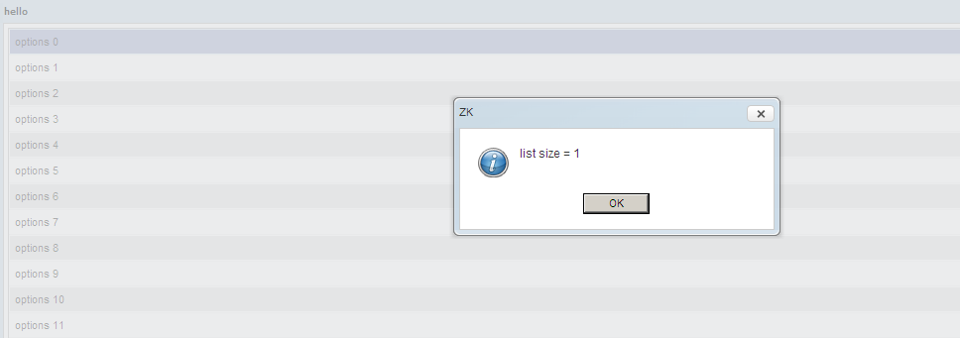

- Now I am selecting multiple rows with shift + click from row 1 to row 10
list size is still 0 and it should have value of 10.

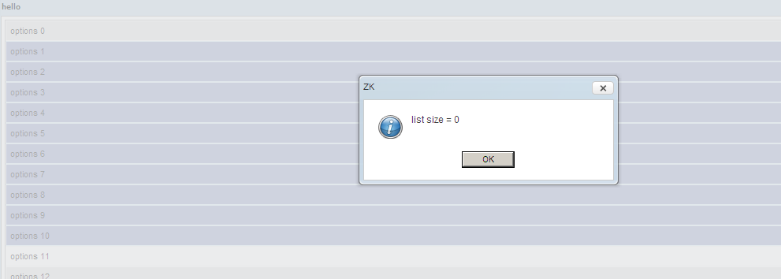

- I am using sample code which you provide.
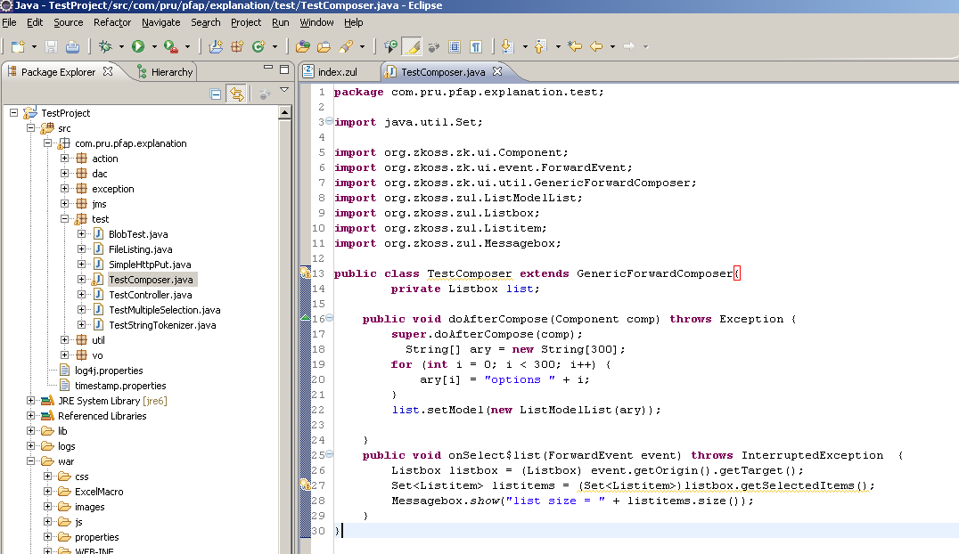

- Here is a zul file.
